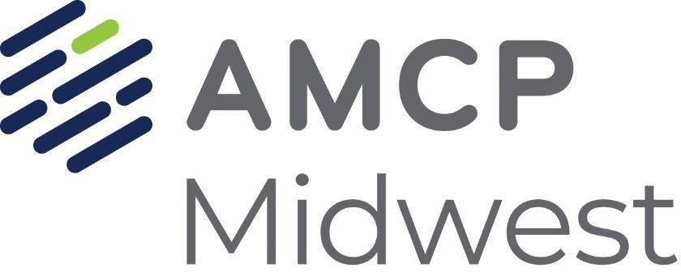

Scholarship Application – AMCP Nexus 2024

AMCP Nexus 2024: October 14th – 17th, 2024

MGM Grand Hotel, Las Vegas, NV

<https://amcpnexus.org/>

**Scholarship(s) of $1,500 each will be awarded to selected PharmD students**

**Eligibility Requirements:** 1. Applicants must be either PharmD student or pharmacy graduate students in good academic standing from an ACPE accredited college or university within Indiana, Illinois, Michigan, Minnesota, or Wisconsin (participating AMCP Midwest states). 2. Applicants must hold an active AMCP student membership. **3. Previous scholarship recipients are not eligible for the next two subsequent national meetings.**

**Deadline:** Sep. 2nd, 2024 by 11:59 pm EST.

**Submit this application to** [**Midwest@amcp.org**](mailto:MidwestAMCP@gmail.com) **with a copy of your CV.**

**Submit all documents (application form and CV) as PDF files.**

**Include as email subject “Scholarship Application for (your full name).”**

|  |  |
| --- | --- |
| **NAME** |  |
| **COLLEGE OF PHARMACY** |  |
| **YEAR IN PHARMACY SCHOOL** |  |
| **ADDRESS** |  |
| **E-MAIL ADDRESS** |  |
| **PHONE #** |  |
| **AMCP MEMBER #** |  |
| To date, what managed care or AMCP activities have you participated in?  **\*\*Maximum 250 words\*\*** | |
|  | |
| What would you like to achieve by attending AMCP Nexus 2024? How would a scholarship help you in attending AMCP Nexus 2024?  **\*\*Maximum 250 words\*\*** | |
|  | |

**Additional Questions**

1. Does your school currently have an AMCP Student Chapter?

Yes  No  No, but I am interested in starting a student chapter

1. Have you attended an AMCP National Meeting in the past?

Yes*  No *If Yes, how many national meetings? ____

1. If available, please provide any of your AMCP student chapter’s platforms (e.g., website, Facebook, LinkedIn, Instagram): _________________________

Scholarship recipients are expected to attend AMCP Nexus 2024 and other Midwest Affiliate events during the conference. In the event the scholarship recipient is unable to attend, the scholarship recipient will notify the Midwest Board as soon as possible.

**SUBMISSION INFORMATION**

**Submit this application to** [**Midwest@amcp.org**](mailto:MidwestAMCP@gmail.com) **with a copy of your CV.**

**Submit all documents (application form and CV) as PDF files.**

**Include as email subject “Scholarship Application for (your full name).”**

**Eligibility Requirements:** 1. Applicants must be either PharmD student or pharmacy graduate students in good academic standing from an ACPE accredited college or university within Indiana, Illinois, Michigan, Minnesota, or Wisconsin (participating AMCP Midwest states). 2. Applicants must hold an active AMCP student membership. **3. Previous scholarship recipients are not eligible for the next two subsequent national meetings.**